13 Early Stage Researchers in Marie Sklodovska-Curie Innovative Training Network
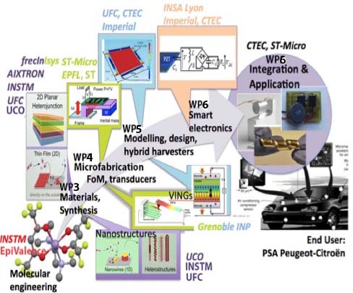
Multidisciplinary guiding principle, workpackages (WP), and contribution of project partners in ETN ENHANCE

Project title: "Piezoelectric Energy Harvesters for Self-Powered Automotive Sensors: from Advanced Lead-Free Materials to Smart Systems (ENHANCE)"

We offer 13 PhD positions with very competitive salaries in Italy, Germany, UK and France:

Two positions at University of Catania/INSTM
Catania, Italy, https://www.unict.it/en/ & http://www.instm.it/en/instm.aspx
Contact: gmalandrino@unict.it
- ESR1: Engineering of metal-organic precursors from synthesis to mechanistic aspects
(WP2(5%), WP3(95%)) Supervisor: G. Malandrino
- ESR3 : Multiferroic films and nanostructures for hybrid energy harvesters
(WP2(5%),WP3 (55%), WP4 (40%)) Supervisors: G. Malandrino & G.G. Condorelli

One position at AIXTRON
Aachen, Germany,
Contact: M.Heuken@aixtron.com
- ESR2 : Modelling and simulations of CVD processes
(WP2(30%),WP3 (70%)) Supervisor: M. Heuken

Two positions at Institute FEMTO-ST, University of Franche-Comté
Besançon, France, www.femto-st.fr & www.univ-fcomte.fr
Contact: ausrine.bartasyte@univ-fcomte.fr
- ESR4 : Piezoelectric and pyroelectric films and nanostructures for hybrid energy harvesters (WP2(5%), WP3 (55%), WP4 (40%)) Supervisors: A. Bartasyte & B. Dulmet
- ESR9 : Design of mechanical structure and electronic interface of hybrid energy harvesters (WP2(10%), WP4 (20%), WP5 (25%),WP6 (45%)) Supervisors: M. Rokotondrabe (UFC), M. Lallart & P.J. Cottinet (INSA Lyon)

Two positions at University of Cologne
Cologne, Germany, https://www.portal.uni-koeln.de/uoc_home.html?&L=1
Contact: sanjay.mathur@uni-koeln.de
- ESR5 : Growth of piezoelectric nanostructures and films for vibrational energy harvesters
(WP2(5%), WP3 (55%), WP4 (40%)) Supervisor: S. Mathur
- ESR6 : Self-supported nanomeshes of piezoelectric materials for vibrational energy harvesters (WP2(5%), WP3 (55%), WP4 (40%)) Supervisor: S. Mathur

One position at ST-Microelectronics
Catania, Italy, http://www.st.com/content/st_com/en/about/careers/st-locations/emea/italy/catania.html
Contact: rosa.previti@st.com
- ESR7 : Simulation and design of autonomous sensor systems and microfabrication processes (WP2-30%, WP4-70%) Supervisors: S. Rinaudo (ST) & G. Malandrino (INSTM)

One position at IMEP-LAHC, Grenoble Institute of Technology
Grenoble, France, http://imep-lahc.grenoble-inp.fr/grenoble, http://www.grenoble-inp.fr/
Contact: Laurent.Montes@grenoble-inp.fr
- ESR8 : Vertical nanowire integrated nanogenerators based on nanostructures with high K² (WP2(5%), WP4 (55%), WP5 (40%)); Supervisors: L. Montes

Two positions at London Imperial College
London, UK, https://www.imperial.ac.uk/
Contact: m.kiziroglou@imperial.ac.uk
- ESR10 : Integrated electromagnetic / piezoelectric motion power supply
(WP2(5%), WP4 (20%), WP5 (55%) and WP6 (20%)); Supervisor: P. Mitcheson
- ESR11 : Energy harvesting based on hybrid transduction mechanisms (WP2(10%), WP4(20%), WP5(35%), WP6 (35%)); Supervisor: P. Mitcheson

One position at LGEF, INSA Lyon
Lyon, France, http://lgef.insa-lyon.fr/
Contact : mickael.lallart@insa-lyon.fr
- ESR12 : Electronics interface for efficient energy harvesting from microscale transducers and micro-scale transducer arrays (WP2(10%),WP6 (90%)); Supervisors: D. Gyomar, M. Lallart & P.J.Cottinet (INSA)

One position at Cedrat Technologies
Meylan, France, www.cedrat-technologies.com,
Contact: projects@cedrat-tec.com
- ESR13 : Simulation and design of nonlinear hybrid harvester systems, their integration and testing (WP2(30%), WP6(70%)); Supervisors: F. Claeyssen & F. Bourgain (CTEC) and M. Lallart & D. Audigier (INSA)

For more details concerning the PhD topics, please, contact directly the representers of employing institutions (email addresses are given above).

Qualifications & experience:
- Master degree or equivalent degree which formally entitle to embark on a doctorate;
- Fluent English (oral and written);
- Excellent IT skills (Microsoft office, image editors);
- Background and expertise in the field of PhD topic;
- Must not have resided or carried out main activity (work, studies, etc) in the country of host organisation for more than 12 months in the last 3 years (short stays for holidays do not count);
- Must be in the first four years of full-time equivalent research experience of their research careers (starting from the date when the degree enabling the access to the PhD studies was obtained)
- Have not been awarded a doctoral degree,

Personal skills:
-High motivation, excellent interpersonal skills, good time and stress management, excellent written and oral skills

How to apply:
In order to apply, send by email to project coordinator Ausrine Bartasyte, ausrine.bartasyte@univ-fcomte.fr:
- CV (2 pages)
- Diploma (copy) of Master degree or equivalent degree which formally entitle to embark on a doctorate, including annexes with marks/classifications.
- Cover letter (1 page)
- Names and contact details of two referees, who agreed to provide recommendation letters
- List of selected Phd topics in order or preference

For application go to the link :
https://euraxess.ec.europa.eu/jobs/209340.
Applications should be submitted electronically before the 1st July 2017.

Per ulteriori informazioni contattare Prof. G. Malandrino (gmalandrino@unict.it)

